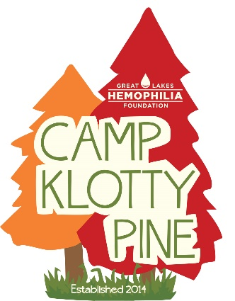
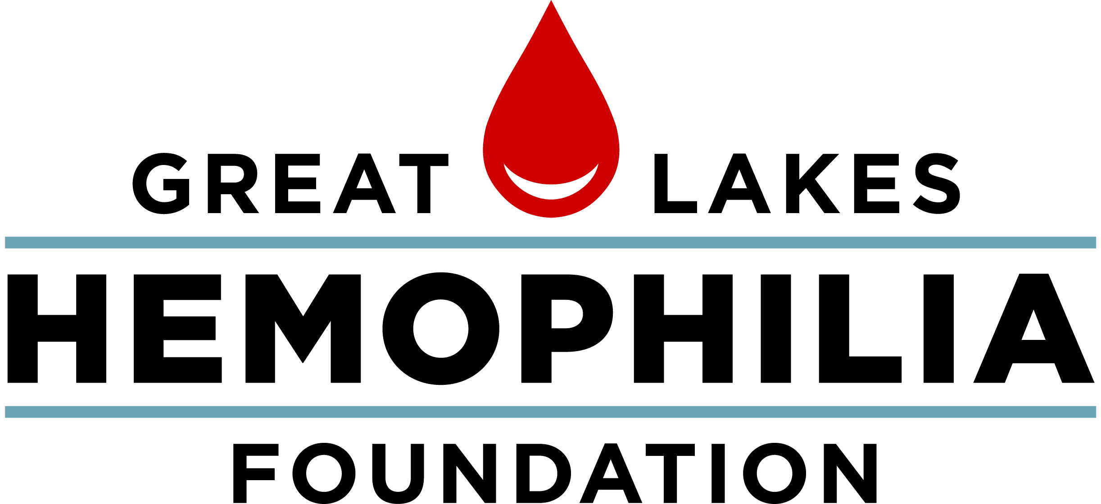

638 N. 18th St., Milwaukee, WI 53233 888.797.4543 414.937.6784

kfrederick@glhf.org glhf.org

DUE: MARCH 1, 2020
2020 Leader in Training Program
Reference Form

Applicant’s Name: ____________________________ Date: ____________________________
The person above is applying to work with children in a residential camp setting. Your assessment of his/her ability to work with children is essential to us. All evaluations will be kept in strict confidence and will not be shared with the applicant. Only upon receiving this reference can the applicant be considered for this program.
Your Name: ____________________________ Title___________________________________________
What is your relationship with the applicant? _______________________________________________

How long have you known this applicant? __________________________________________________

Preferred contact information: ___________________________________________________________

Please rate the applicant’s traits on the scale below by marking the appropriate column.
 | POOR  1 | NEEDS WORK  2 | SOLID  3 | GOOD  4 | EXCEPT  IONAL  5 | N/A | Comments
Leadership
Engaging, Positive, Encouraging
Teamwork
Cooperative, Collaborative, Fair, Respectful, Flexible
Responsibility
Time management, completes tasks, Honest
Maturity
Self-Control, Self-aware, Accountable
Communication
Active listener, compassionate,
Work Ethic
Passionate, self-motivated, accepts constructive criticism
Decision Making
Rational, Inclusive, purposeful
Additional Notes:
Why would this applicant be good at working with children in a residential camp setting?

Camp can be very demanding, requiring long hours, physical work and emotional maturity. Do you think the applicant would be suitable for the position in this regard? If yes, how have you seen them demonstrate these qualities or skills? If no, how could we help them to succeed?

In your opinion, what traits does this individual possess that would make a good leader?

What are the applicant’s area’s needing growth? If chosen, in what ways can we provide this applicant support to help him/her be successful in this position?

Please return this reference form to Kailee Frederick at Great Lakes Hemophilia Foundation. Please call or email if you have any questions or concerns. Thank you!

Email: Kfrederick@glhf.org
Address:
Great Lakes Hemophilia Foundation
638 N. 18th St. Suite 108
Milwaukee, WI 53233
Fax: 414.257.1225
Phone: 414.937.6784

