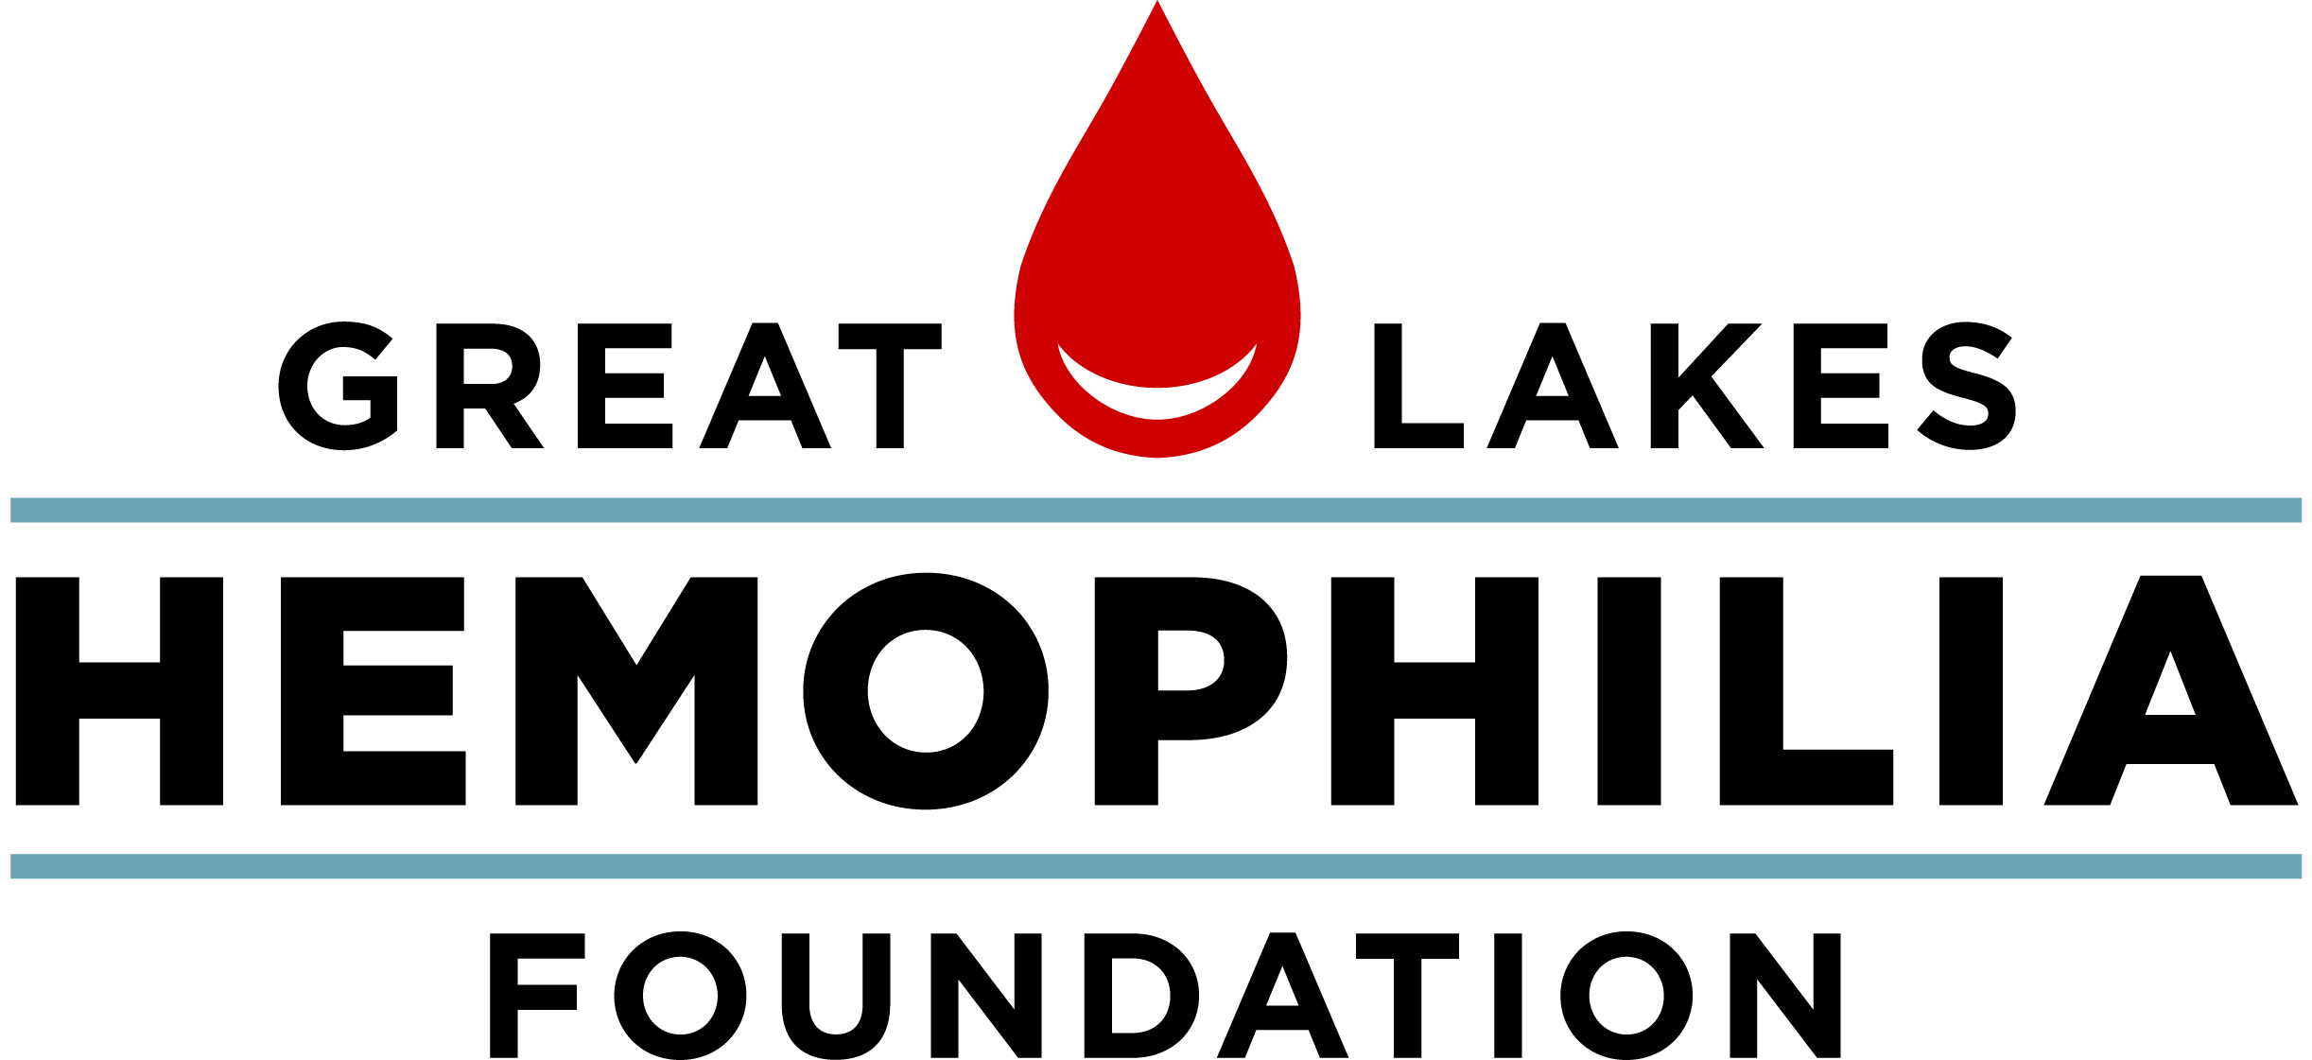
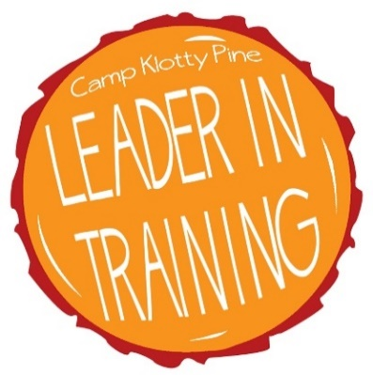

638 N. 18th St., Milwaukee, WI 53233 888.797.4543 414.937.6784

kfrederick@glhf.org glhf.org

Leader in Training Application 2019

- General Information

Applicant Information
Last Name |  |  |  |  | First |  |  |  | M.I.
Street Address |  |  |  |  |  |  |  |  | Apartment/Unit #
City |  |  |  |  | State |  |  |  | ZIP
Phone |  |  |  |  | Birthdate
Email
Parent Email
**Please check your email listed above on a regular basis. **
**This is our main way of communicating information to you! **
Hemophilia Treatment Center
or Hematologist
Have you attended Camp Klotty Pine as a camper before? |  |  | YES | NO |  | If so, what years?
Have you been an LIT at Camp Klotty Pine before? |  |  | YES | NO |  | If so, what years?

Education
High School |  |  | Address
Grade |  |  | Expected Graduation Date

EMERGENcY Contact
Parent/Guardian #1 Name |  |  |  |  | Relationship:
Phone Number
Parent/Guardian #1 Name |  |  |  |  | Relationship:
Phone Number

2. Essay Questions

We would like to get to know you through the application material and believe that your thoughtful, well-constructed short answer questions are an important step in the process. Your answers should be of sufficient length to demonstrate your writing ability and do justice to the topic, please write responses no less than 50 words for each of the questions below. Your responses MUST accompany your application.

New LITS

- Do you engage in any hobbies or activities on a regular basis? What are they, and why do you enjoy them?
- Tell us about any experience you have working with youth that would be relative to your position at camp. (Volunteering, babysitting, classes, workshops)
- Describe your involvement, if any, with the bleeding disorders community.
- What some goals for yourself that you wish to develop as a leader?
- As and LIT, how would you contribute to the goals and mission of Camp Klotty Pine?
“The mission of Camp Klotty Pine is to enhance the lives of children affected by a bleeding disorder by providing life-changing camp experiences that are exciting, empowering and educational, in a physically safe and medically sound environment.”

Returning LITs

- How do you feel you have improved as a counseling figure after last summer at Camp Klotty Pine?
- What do you feel you still need to improve upon?
- What do you feel your strengths are at camp? In other words, what do you bring to camp?
- What other experiences (youth groups, volunteer work, work experience) do you have that you think will help you be a successful LIT?
- What are three goals you have for the upcoming summer?

3. References
For this next part, if you are applying to be a 1st or 2nd year LIT ask three adults to complete the reference form attached to this application. If you are applying to be a 3rd year LIT ask one adult to write you a letter of recommendation. The references you choose should know you well, and share a professional or academic relationship (e.g. teacher, coach, band director, job supervisor, HTC social worker or nurse etc.). Please have your references send the completed forms or letters separately to Kailee Frederick at GLHF via fax, email, or mail.

Full Name |  | Email
Relationship |  | Phone
Full Name |  | Email
Relationship |  | Phone
Full Name |  | Email
Relationship |  | Phone

